EEE 120
Lab 2 Answer Sheet
Multiplexers, Decoders and the Arithmetic and Logic Unit (ALU)
Name: Dylan Shah
Instructor/Time: Dr. Steve Millman Tu Th 3:00 PM - 4:15 PM Date: January 13, 2026

Task 2-1: Build and Test a 1-Bit 2:1 Multiplexer
Include a picture of your Digital circuit here:
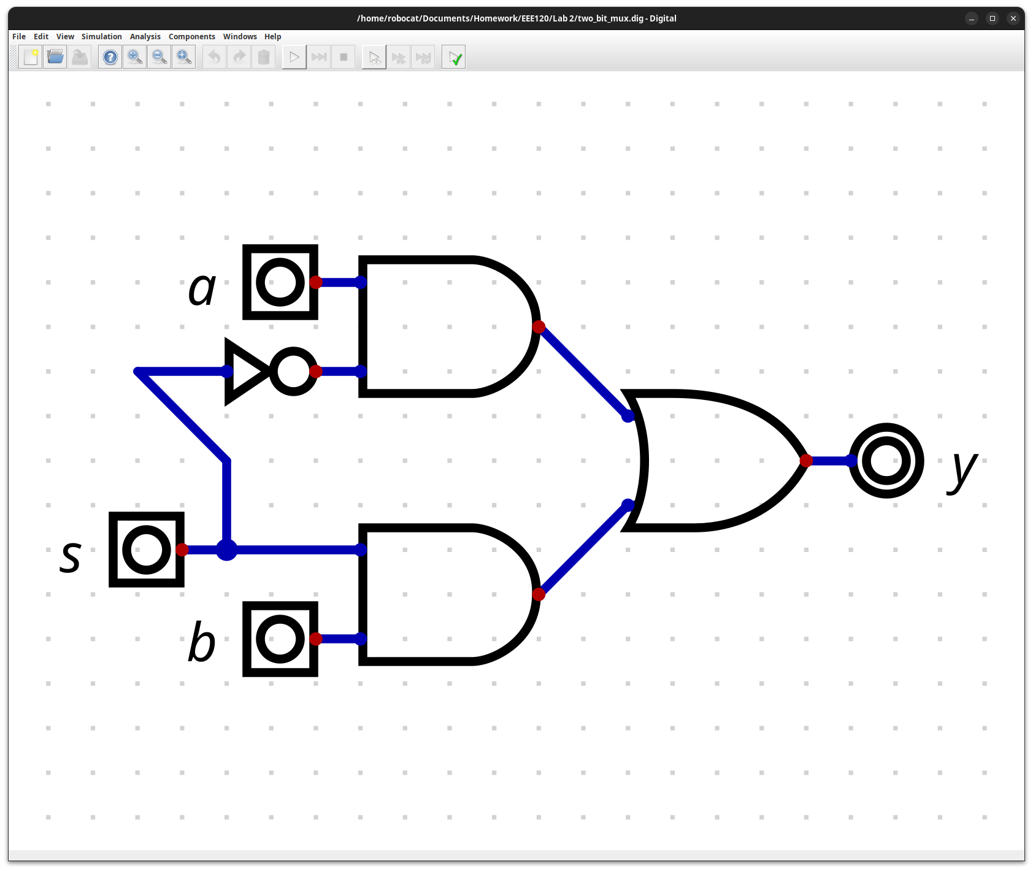
Please comment on the single biggest issue you were facing when designing the circuit.
I did not have any issues designing the circuit.

Task 2-2: Build a 4-Bit 2:1 Multiplexer
Include a picture of your Digital circuit here:
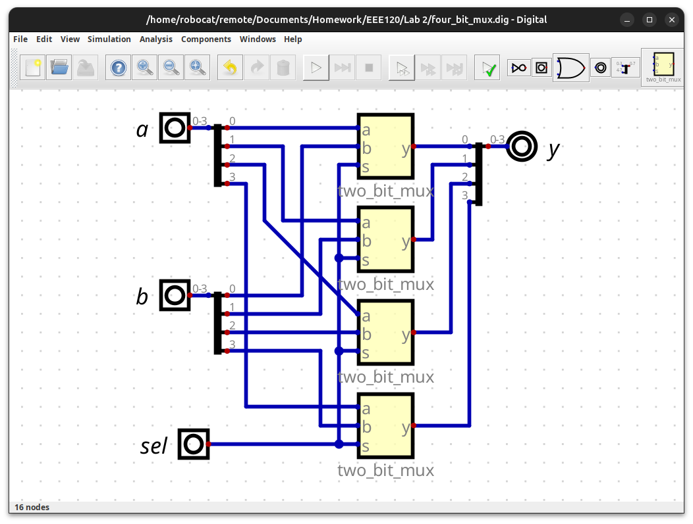
Please comment on the single biggest issue you were facing when designing the circuit.
The connection between a.2 and the mux would have the wire going where I already routed wires for b, so I had to make a diagonal wire for it, unfortunately.
Include a picture of your simulation (timing diagram) here:
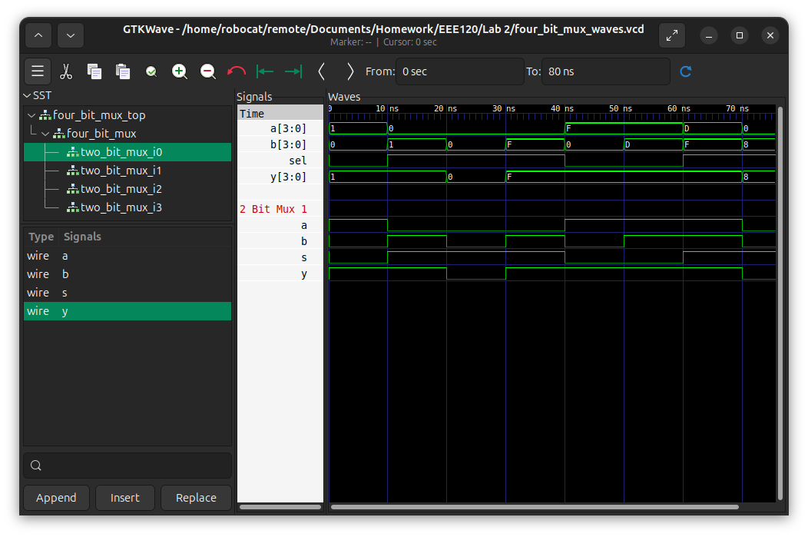
Which tests did you perform and why? Use the following table to describe your test sequence. You need to make sure to perform enough tests to check the circuit for possible incorrect behavior.
Test Stimulus | Test Motivation | Pass/Fail
1_0_1_0 | Test the first bit is switched when sel is off. | PASS
1_1_0_1 | Test the first bit is switched when sel is on. | PASS
0_1_0_0 | All zeros pass through | PASS
F_1_0_F | All ones pass though | PASS
F_0_F_0 | All ones pass though | PASS
F_0_F_D | Changing inactive input has no effect | PASS
F_1_D_F | Changing inactive input has no effect | PASS
8_1_0_8 | Order of bits is same | PASS

Please comment on the single biggest issue you were facing when simulating the circuit.
I did not face any issues simulating the circuit.

Task 2-3: Add 7-Segment Displays to Your Circuit
Include a picture of your Digital 7-Segment Display here:
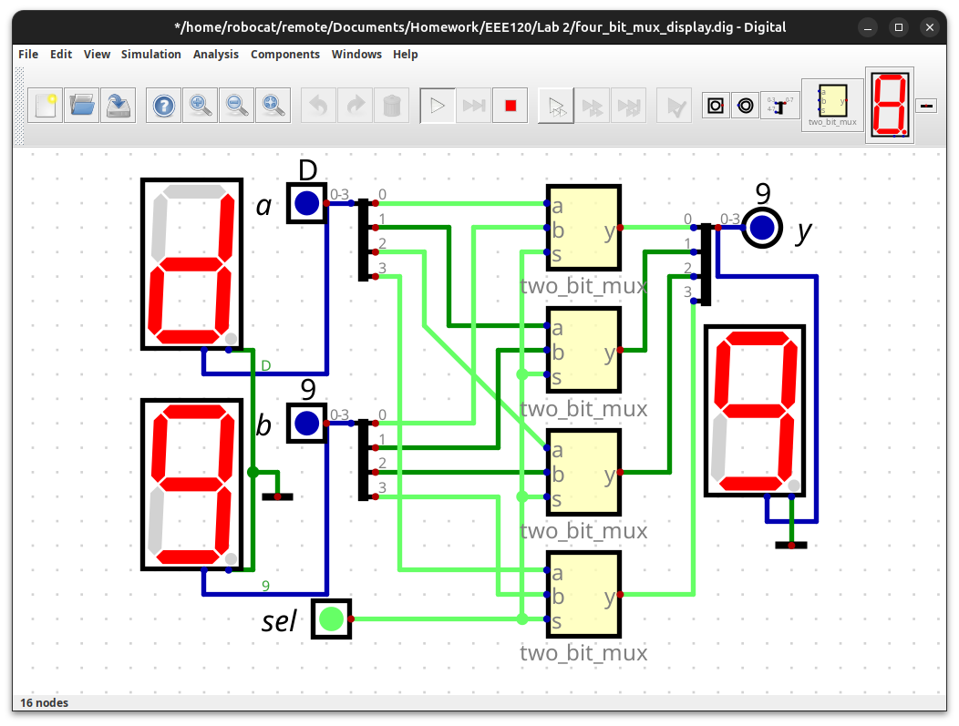
Please comment on the single biggest issue you were facing when adding the displays.
The component was much larger than I thought, and I struggled to find space for it.

Task 2-4: Build the NOT/NEG Circuit
Include a picture of your Digital circuit here:
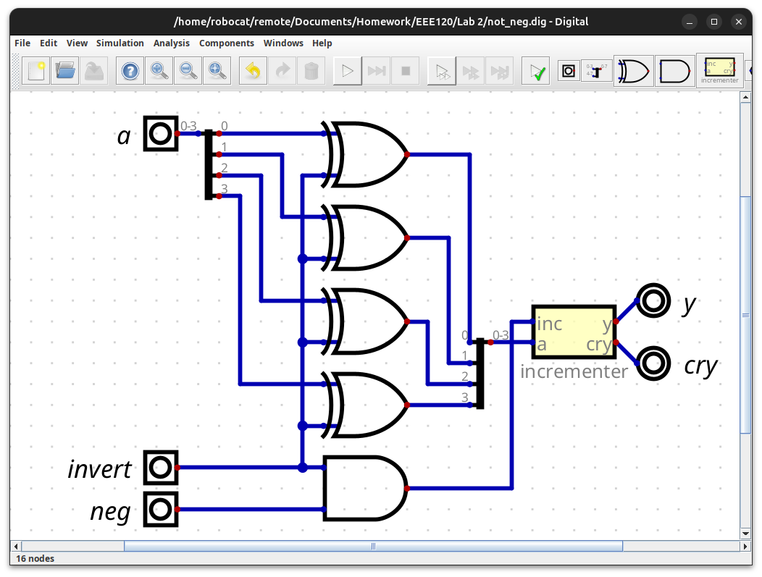
Please comment on the single biggest issue you were facing when designing the circuit.
The labels on my incrimenter were in the opposite order of what was in the example, which tripped me up on my first attempt routing the wires.

Task 2-5: Build the AND/ADD Circuit
Include a picture of your Digital circuit here:
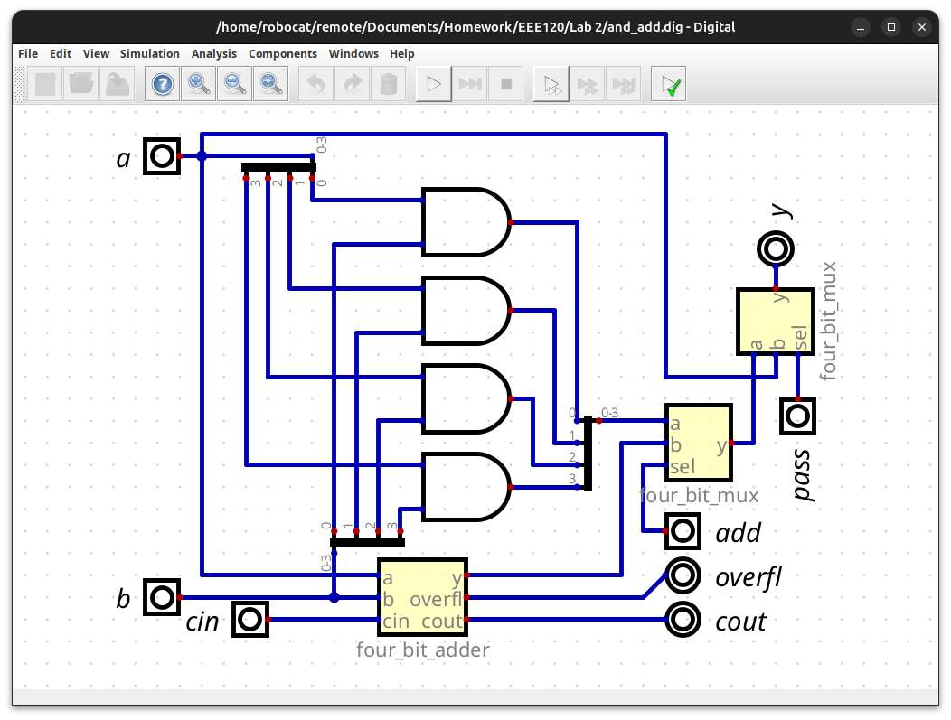
Please comment on the single biggest issue you were facing when designing the circuit.
I did not experience any issues creating this circuit.

Task 2-6: Build and Test the ALU Circuit
Include a picture of your Digital circuit here:
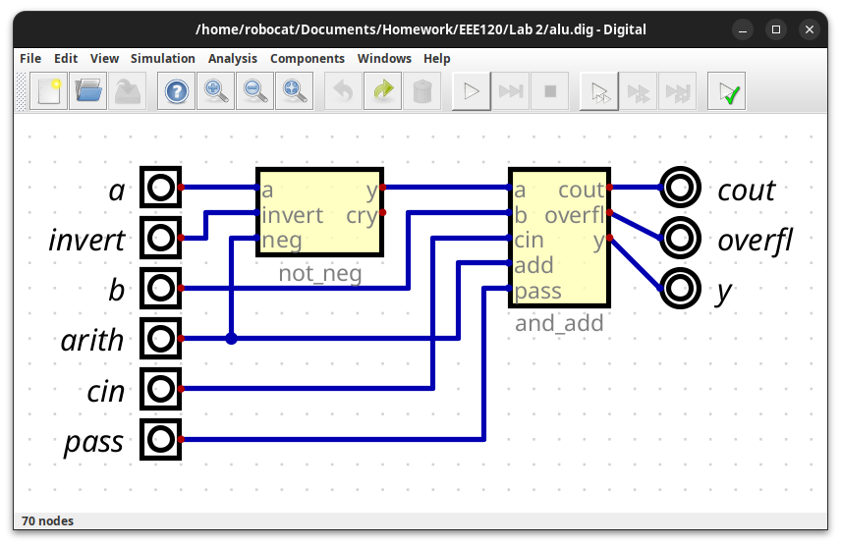
Please comment on the single biggest issue you were facing when designing the circuit.
I did not have any difficulties designing the circuit.
Please complete the ALU function definition table shown below:
arith | invert | pass | Function
0 | 0 | 0 | AND, AB
0 | 0 | 1 | PASS THROUGH, A
0 | 1 | 0 | NOT A AND B, ĀB
0 | 1 | 1 | INVERT A, Ā
1 | 0 | 0 | Arithmetic Sum, A+B
1 | 0 | 1 | PASS THROUGH, A
1 | 1 | 0 | SUBTRACT, B-A
1 | 1 | 1 | NEGATE A, -A

Include all pictures of simulations (timing diagrams) for each function here. With each picture, paste the test_vals from your stimulus file for that test.
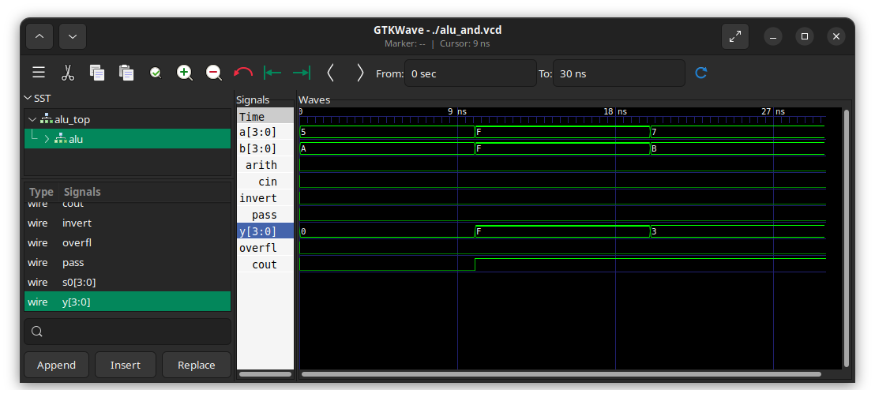
test_vals[0] = 18'h0_0_0_5_A; // Ensure all bits can turn off
test_vals[1] = 18'h0_F_0_F_F; // Ensure all bits can turn on
test_vals[2] = 18'h0_3_0_7_B; // Ensure some bits can turn on and some off
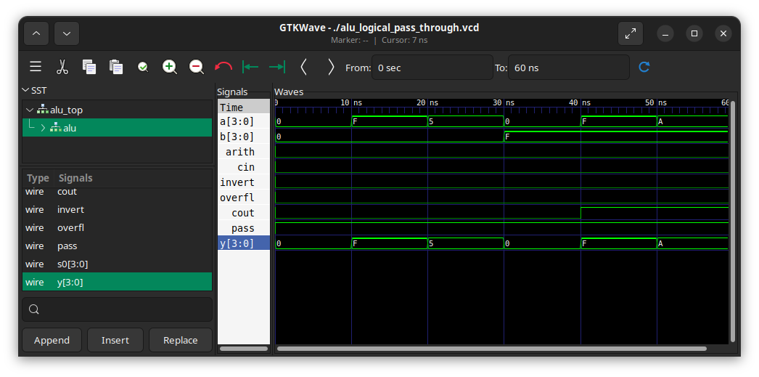
test_vals[0] = 18'h0_0_1_0_0; // Ensure there are no stuck on bits
test_vals[1] = 18'h0_F_1_F_0; // Ensure there are no stuck off bits
test_vals[2] = 18'h0_5_1_5_0; // Ensure bit ordering stays the same
test_vals[3] = 18'h0_0_1_0_F; // Ensure B does not affect A
test_vals[4] = 18'h0_F_1_F_F; // Ensure B does not affect A
test_vals[5] = 18'h0_A_1_A_F; // Ensure B does not affect A
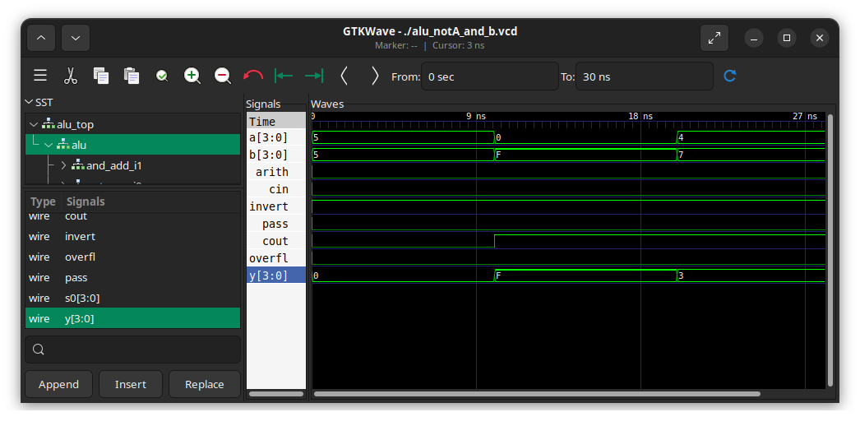
test_vals[0] = 18'h0_0_2_5_5; // Ensure all bits can turn off
test_vals[1] = 18'h0_F_2_0_F; // Ensure all bits can turn on
test_vals[2] = 18'h0_3_2_4_7; // Ensure some bits can turn on and some off0
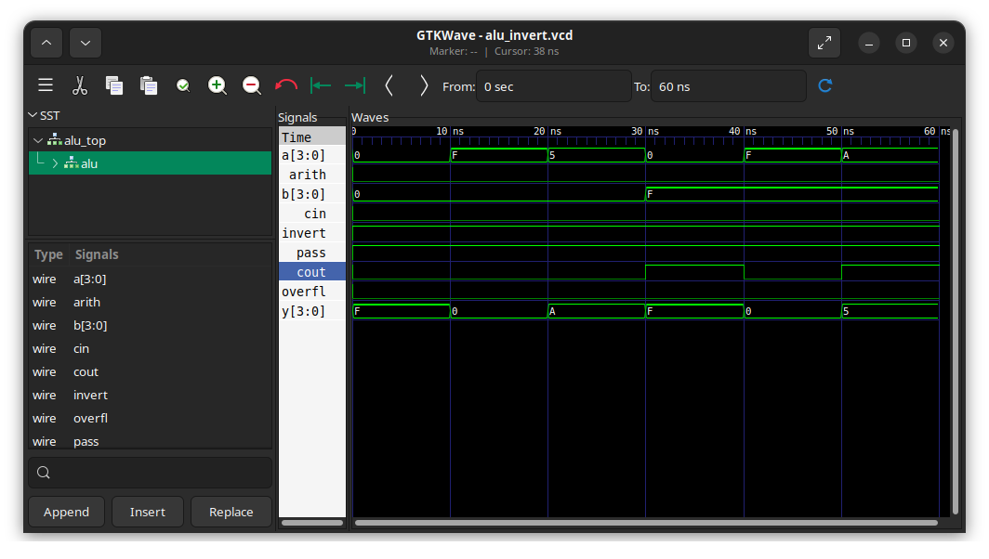
test_vals[0] = 18'h0_F_3_0_0; // Ensure there are no stuck on bits
test_vals[1] = 18'h0_0_3_F_0; // Ensure there are no stuck off bits
test_vals[2] = 18'h0_A_3_5_0; // Ensure bit ordering stays the same
test_vals[3] = 18'h0_F_3_0_F; // Ensure B does not affect A
test_vals[4] = 18'h0_0_3_F_F; // Ensure B does not affect A
test_vals[5] = 18'h0_5_3_A_F; // Ensure B does not affect A
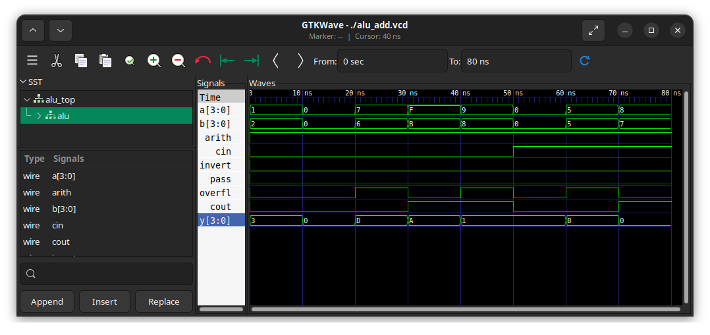
test_vals[0] = 18'h0_3_4_1_2; // Check small numbers add correctly
test_vals[1] = 18'h0_0_4_0_0; // Check that there are no stuck bits
test_vals[2] = 18'h2_D_4_7_6; // Check that one large unsigned number and a smaller number add correctly
test_vals[3] = 18'h1_A_4_F_B; // Check that two negative numbers add correctly with no overflow
test_vals[4] = 18'h3_1_4_9_8; // Check that overflow happens correctly.
test_vals[5] = 18'h0_1_C_0_0; // Check Cin adds correctly
test_vals[6] = 18'h2_B_C_5_5; // Check Cin adds correctly
test_vals[7] = 18'h1_0_C_8_7; // Check Cin adds correctly, and -(-8) = -8, as there is no positive representatation
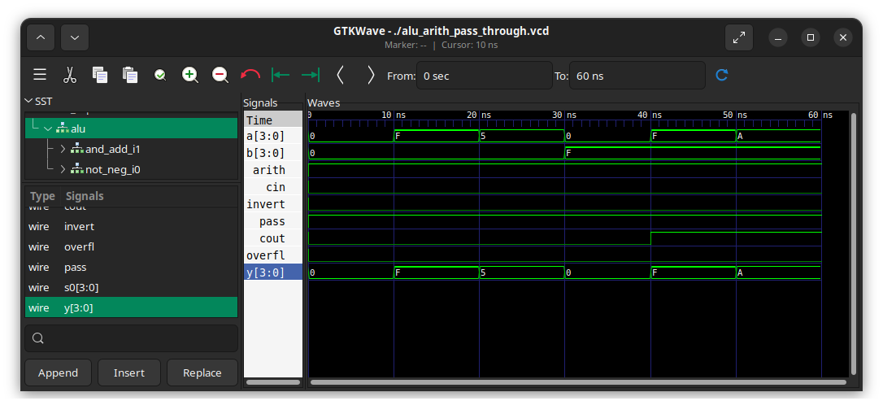
test_vals[0] = 18'h0_0_5_0_0; // Ensure there are no stuck on bits
test_vals[1] = 18'h0_F_5_F_0; // Ensure there are no stuck off bits
test_vals[2] = 18'h0_5_5_5_0; // Ensure bit ordering stays the same
test_vals[3] = 18'h0_0_5_0_F; // Ensure B does not affect A
test_vals[4] = 18'h0_F_5_F_F; // Ensure B does not affect A
test_vals[5] = 18'h0_A_5_A_F; // Ensure B does not affect A
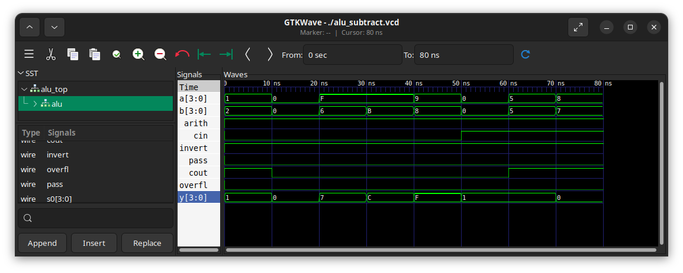
test_vals[0] = 18'h1_1_6_1_2; // Check small numbers subtract correctly
test_vals[1] = 18'h0_0_6_0_0; // Check that there are no stuck bits
test_vals[2] = 18'h0_7_6_F_6; // Check that a number minus a negative number is their sum
test_vals[3] = 18'h0_C_6_F_B; // Check that two negative numbers subtract correctly with no overflow
test_vals[4] = 18'h0_F_6_9_8; // Check that overflow happens correctly.
test_vals[5] = 18'h0_1_E_0_0; // Check Cin adds to the difference correctly
test_vals[6] = 18'h1_1_E_5_5; // Check Cin adds to the difference correctly
test_vals[7] = 18'h1_0_E_8_7; // Check Cin adds to the difference correctly, and -(-8) = -8, as there is no positive representation
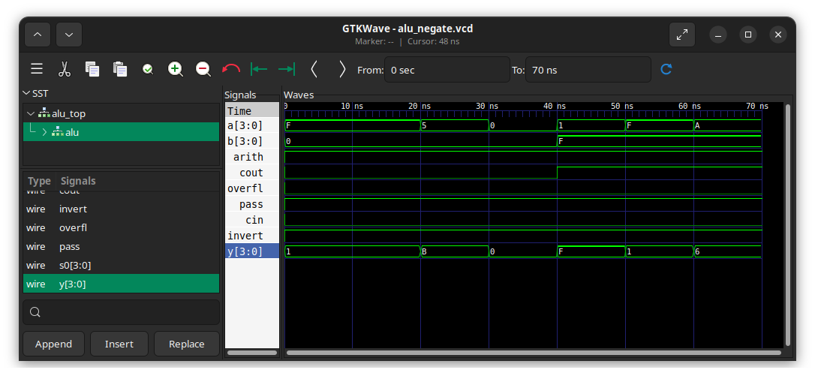
test_vals[0] = 18'h0_1_7_F_0; // Ensure there are no stuck on bits
test_vals[1] = 18'h0_1_7_F_0; // Ensure there are no stuck off bits
test_vals[2] = 18'h0_B_7_5_0; // Ensure bit ordering stays the same
test_vals[3] = 18'h0_0_7_0_0; // Ensure -0 = 0
test_vals[4] = 18'h0_F_7_1_F; // Ensure B does not affect A
test_vals[5] = 18'h0_1_7_F_F; // Ensure B does not affect A
test_vals[6] = 18'h0_6_7_A_F; // Ensure B does not affect A
Did the circuit behave as expected? If no, what was wrong? Yes, the circuit works as expected.
Please comment on the single biggest issue you were facing when simulating the circuit.
I was struggling to think of what tests are needed to ensure the circuit works as expected.

Task 2-7: Create a video and submit your report
Record a short video showing your schematics in Digital and your waveforms in GTKWave. Be sure to show yourself in the video and show your screen. Explain how your circuit works – you need to convince the grader you did the lab and understand it! Copy and paste the link to your video below. Make sure the link is working and pointing to the correct video. Remember to include the password if required. Do NOT upload your video to Canvas. It is recommended that you use Zoom to record to the cloud, pasting the link and password below. If your circuit is not working as expected, explain in the video how it is not working and why you think it is not working.
Video Link: https://drive.google.com/file/d/1irdxSqPzMCkJTAj3BQAshP16h56tdms1/view?usp=drive_link
At the beginning of your recording, say your name and the lab name. Be brief in your recording. Submit the completed template to Canvas.
Make sure all your files are in the Lab2 directory. Create a zip file of the Lab2 directory. Remember to turn in the zip file and your completed template on Canvas!
Do not include the video in the zip file! This makes the file very large and you run the risk of the zip file not uploading or taking so long to upload that your submission will be late. Remember that the submission is dated at the time the upload completes, not when it starts!

Lab 2: Lab Report Grade Sheet

Name:

NOTE: You submit the zip file in order to show your work.
If the zip file is not submitted you will receive a 0 for this lab!

Instructor Assessment
Grading Criteria | Max Points | Points Lost
Description of Assigned Tasks, Work Performed & Outcomes Met
Task 2-1: Build and Test a 1-bit 2:1 Multiplexer | 5
Task 2-2: Build a 4-Bit 2:1 Multiplexer | 5
Task 2-3: Add 7-Segment Displays to Your Circuit | 5
Task 2-4: Build the NOT/NEG Circuit | 5
Task 2-5: Build the AND/ADD Circuit | 10
Task 2-6: Build and Test the ALU Circuit | 10
Task 2-7: Create a video and submit your report. | 10
 | Points Lost
Lab Score (50 points total) | Late Lab
 | Lab Score

